Project Title: Currency Converter
Description:
The Currency Converter is a menu-driven application developed using the Java programming language. The main objective of this project is to convert monetary values between three currencies: US Dollar (USD), Indian Rupee (INR), and Euro (EUR).
The application provides six conversion options: USD to INR, INR to USD, EUR to INR, INR to EUR, USD to EUR, and EUR to USD. The user selects a conversion option from the displayed menu and enters the amount to be converted. The program then calculates the converted amount using predefined exchange rates and displays the result.
The program uses the Scanner class to accept input from the user, constants to store exchange rates, a while loop to repeatedly display the menu, if-else statements to validate the user's choice, and a switch statement to perform the selected conversion.
The application continues running until the user selects the exit option. It also displays an error message when the user enters an invalid menu choice.
This project helps beginners understand Java fundamentals, including variables, data types, constants, user input, operators, conditional statements, loops, switch-case statements, and basic program control.
Objectives of the Project
The main objectives are:
- To understand the basic structure of a Java program.
- To learn how to accept input from the user.
- To perform arithmetic calculations using the multiplication operator.
- To use constants to store predefined exchange rates.
- To implement decision-making using if-else and switch-case.
- To use a loop for repeatedly displaying a menu.
- To validate the user's menu selection.
- To understand how a simple real-world application can be developed using Java.

Working Procedure of the Program
Step 1: Start the program
Initialize exchange rates and Scanner.
Step 2: Display the menu
Show six conversions and the exit option.
Step 3: Read the user's choice
Accept an integer using nextInt().
Step 4: Check the choice
Exit, perform a conversion, or display an error.
Step 5: Calculate and display
Read the amount, multiply by the rate, and print the result.
Step 6: Repeat or exit
Return to the menu or close the Scanner and finish.

Program:
import java.util.Scanner;
public class CurrencyConverter {
public static void main(String[] args) {
// Fixed exchange rates stored as constants using 'final'
final double USD_TO_INR = 83.50;
final double INR_TO_USD = 0.012;
final double EUR_TO_INR = 90.20;
final double INR_TO_EUR = 0.011;
final double USD_TO_EUR = 0.92;
final double EUR_TO_USD = 1.09;

Scanner scanner = new Scanner(System.in);
boolean keepRunning = true;

while (keepRunning) {
System.out.println("\n--- CURRENCY CONVERTER MENU ---");
System.out.println("1. Convert USD to INR");
System.out.println("2. Convert INR to USD");
System.out.println("3. Convert EUR to INR");
System.out.println("4. Convert INR to EUR");
System.out.println("5. Convert USD to EUR");
System.out.println("6. Convert EUR to USD");
System.out.println("7. Exit the program");
System.out.print("Enter your choice (1-7): ");

int choice = scanner.nextInt();

if (choice == 7) {
keepRunning = false;
System.out.println("Exiting program. Goodbye!");
} else if (choice >= 1 && choice <= 6) {
System.out.print("Enter amount to convert: ");
double amount = scanner.nextDouble();
double result = 0.0;

switch (choice) {
case 1:
result = amount * USD_TO_INR;
System.out.println(amount + " USD = " + result + " INR");
break;
case 2:
result = amount * INR_TO_USD;
System.out.println(amount + " INR = " + result + " USD");
break;
case 3:
result = amount * EUR_TO_INR;
System.out.println(amount + " EUR = " + result + " INR");
break;
case 4:
result = amount * INR_TO_EUR;
System.out.println(amount + " INR = " + result + " EUR");
break;
case 5:
result = amount * USD_TO_EUR;
System.out.println(amount + " USD = " + result + " EUR");
break;
case 6:
result = amount * EUR_TO_USD;
System.out.println(amount + " EUR = " + result + " USD");
break;
}
} else {
System.out.println("Invalid choice! Please select 1 to 7.");
}
}
scanner.close();
}
}

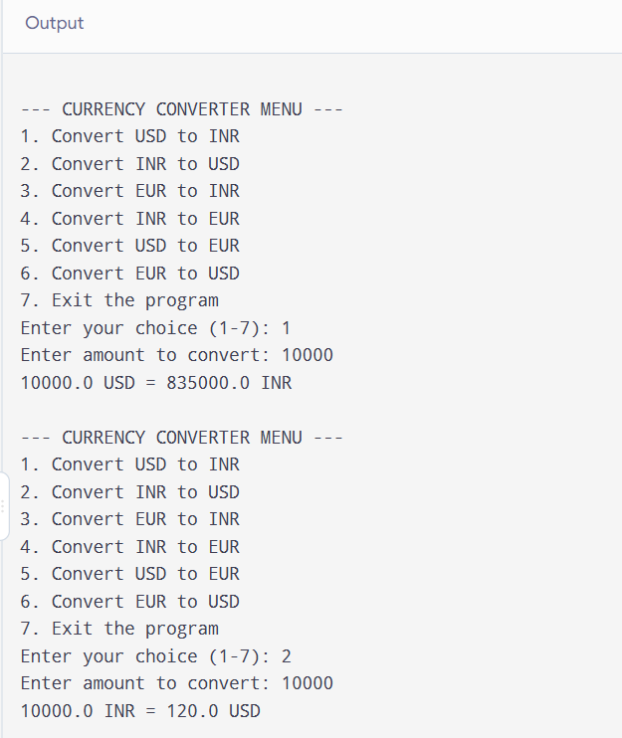
Output:



